Report 2
(Week 14 Report Documentation)
Prepared by:
Tsundzukani Nkuna
From Date:
2025/ 05/ 10
To Date:
2025/ 06/ 27
Contents
Software Development: - (Applications Development) 2
1.1 Application of Agile software development approach 2
1.1.1 Agile Overview 2
1.1.2 What is Agile Software Development? 2
1.1.3 Agile Development Cycle 3
1.1.4 Advantages and Disadvantages of Agile 3
1.2 Application of Project scheduling using tools (such as MS Projects) 3
1.2.1 Software Development Project 3
1.3 Application of concept illustration tools (such as MS Visio) 4
1.3.1 Software Architecture Diagrams 4
1.3.2 Database Design (ER Diagrams) 4
1.3.3 Software Development Lifecycle (SDLC) Visualization 4
1.3.4 UML Diagrams (Unified Modelling Language) 4
1.5 Understanding basic principles of project management (IT projects 5
1.5.1 Principles of Project Management 5
1.6 Conclusion: Principles of Project Management 6
1.7 DATABASE MANAGEMENT SYSTEM 6
1.7.1 Types of DBMS Architecture 6
1.7.1.1 1-Tier Architecture 6
1.7.1.2 2-Tier Architecture 7
1.7.1.3 3-Tier Architecture 7
1.7.2 Core Functions of a DBMS 7
1.8 BUSINESS INTELLIGENCE 8
1.8.1 Data Visualization and Predictive Reporting 8
1.8.2 Key Types of Data Visualizations for Predictive Reporting 8
1.9 DYNAMIC / MULTI PLATFORMS 8
1.9.1 Benefits of Dynamic / Multi-Platform BI 9
1.10 Weekly MIS Technical Report 10
1.10.1 LAST REPORT 10
1.10.2 LAST REPORT 12

Software Development: - (Applications Development)

1.1 Application of Agile software development approach

1.1.1 Agile Overview
Agile project management is based on an incremental, iterative approach.
Instead of in-depth planning at the beginning of the project, Agile methodologies
are open to changing requirements over time and encourages constant
feedback from the end users. The goal of each iteration is to produce a working
product.

Agile refers to any process that aligns with the concepts of the Agile Manifesto.
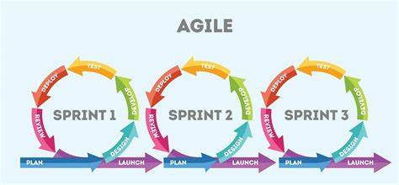

1.1.2 What is Agile Software Development?
It is a methodology, a set of methods and practices.

1.1.2.1 Iterative
- Iteration is the main concept in agile. (All agile methods are iterative!)
- It is the total opposite of the waterfall-model!
- The work is done in tight cycles, so called “sprints “.
- The “plan “is constantly revisited.
  - Streamlined
  - It Favors for getting the work done.
  - Time-boxed
  - The work is planned by time instead of by feature.
  - Very collaborative

1.1.3 Agile Development Cycle
The phases in the Agile development cycle may not happen in succession; they are flexible and always evolving, with many happening in parallel.
- Planning: Once an idea is deemed viable, the project team comes together to identify features, prioritize each feature, and assign them to an iteration.
- Requirements analysis: Key stakeholders and users meet to identify business requirements that are quantifiable, relevant, and detailed.
- Design: The design is prepared from the requirements identified and the team considers what the product or solution will look like, deciding on a test strategy or plan to proceed.
- Implementation, coding or development: Coding or developing features, and scheduling iterations for deployment.
- Testing: Test the code against the requirements to make sure the product is solving customer needs. This phase includes unit testing, integration testing, system testing, and acceptance testing.
- Deployment: Deliver the product to customers. Once customers start using the product, they may run into new problems that the project team will need to address in future iterations.

1.1.4 Advantages and Disadvantages of Agile
Advantages | Disadvantages
Change is embraced | Planning can be less concrete
End-goal can be unknown | Team must be knowledgeable
Faster, high-quality delivery | Time commitment from developers
Strong team interaction | Documentation can be neglected
Customers are heard
Continuous improvement

1.2 Application of Project scheduling using tools (such as MS Projects)
Project scheduling is a crucial component of project management, ensuring that tasks are planned, tracked, and completed on time. Tools like Microsoft Project (MS Project) help manage this effectively.

1.2.1 Software Development Project
Example: Building a Chemical Analysis System
- Tasks Scheduled:
- Requirements gathering
- Hardware integration
- Deployment and testing
- MS Project Features Used:
- Gantt charts for timeline visualization
- Task dependencies (e.g., model training depends on dataset readiness)
- Resource allocation

1.3 Application of concept illustration tools (such as MS Visio)
Concept illustration tools like Microsoft Visio are used to visually communicate complex ideas, processes, systems, or designs. They help teams understand and collaborate on technical and business concepts more effectively.

1.3.1 Software Architecture Diagrams
- Purpose: Show high-level structure and components of the system.
- Example: Display interactions between front-end, back-end, database, APIs, and third-party services.
- Benefit: Helps developers and stakeholders understand system layout before implementation.

1.3.2 Database Design (ER Diagrams)
- Purpose: Visualize tables, relationships, and data structure.
- Example: Show how user data, product data, and transactions are stored and related.
- Benefit: Clarifies database logic and supports DB schema development.

1.3.3 Software Development Lifecycle (SDLC) Visualization
- Purpose: Map out all phases of development (e.g., requirements, design, coding, testing, deployment).
- Example: Show waterfall or Agile process using timeline or swim lane diagrams.
- Benefit: Aligns the team with project stages and deliverables.

1.3.4 UML Diagrams (Unified Modelling Language)
- UML Diagram Use Case
- State Diagram Represent state transitions in a finite-state machine.
- Class Diagram Define object-oriented structure classes, attributes, methods.
- Activity Diagram Model the flow of operations or business processes
- Use Case Diagram Identify actors and their interactions with the system.
- Sequence Diagram Show object interaction over time for specific use cases.

1.5 Understanding basic principles of project management (IT projects
Project Management is a demanding task that requires highly skilled people having complete domain knowledge and good soft skills such as communication, time management, and leadership. Some set principles and methodologies are followed for efficient project management. A project has a predetermined beginning time and ending time, which means that the work is to be carried out within preset deadlines.

1.5.1 Principles of Project Management
The essential guidelines that must be followed to successfully manage projects are known as project management principles.
- Well-defined Goals and Objectives: For an ideal project, goals must be realistic, clear, and measurable. This step of defining goals helps to decide the size of the workforce, make further schedules, and evaluate the success/failure of the project at the evaluation stage.
- Project Organizational Structure: Various procedures and guidelines to be followed for specific tasks should also be clearly defined. This ensures the proper distribution of responsibilities among team members and includes various rules such as how the flow of information should be across various levels.
- Risk Management: Proper risk management plans should also be developed so that if any issue arises during the project work, it can be rectified as soon as possible so that there is no delay in the completion of the project.
- Establish the Project Deliverables: Project deliverables are the tangible and measurable items that are expected as a result or outcome of the project work. For instance, a software development project can have deliverables such as a fully-fledged working application, user manuals, documentation, source code, testing reports, etc.
- Build a Communication Plan: Most of the communication should be in written form such as emails, letters, notices, etc. so that there is a record for that. It becomes crucial when the organizational structure is quite complex and there are various hierarchical levels involved in the team.
- Define Various Performance Baselines: Various team members can contribute to update the progress during the project. Some common types of performance baselines are Schedule baselines, Cost baselines, Quality baselines, etc.
- Define the Priorities of Shareholders: The primary goal of any project in an industry is business profit, so this goal should be clearly defined in quantifiable terms by discussion with the shareholders.
- Ensure Transparency: The project manager should ensure a transparent system where each team member can obtain any project-relevant information quickly and efficiently. For any relevant information access, this should not be there that team members require permission from the team leader as this will cause unnecessary delay in the project work.
- Careful Budgeting and Scheduling: Proper budgeting involves defining all costs associated with the project and monitoring expenses. Scheduling involves defining activities for different timelines, typically daily or weekly. Each team member should follow the schedule provided by the project manager.
- Establish Accountability and Responsibility: The project manager should ensure that team members are accountable, which means that they must accept their actions without any hesitation. This ensures that only reasonable actions are taken. Each team member should also have a sense of responsibility in them so that they do their work with complete dedication and carefulness to avoid any kind of errors.

1.6 Conclusion: Principles of Project Management
In conclusion, project management demands skilled individuals with communication and leadership prowess. Modern project managers adhere to established principles such as goal clarity, risk management, and transparent communication. These principles provide a framework for successful project execution, ensuring efficient resource allocation, risk mitigation, and stakeholder satisfaction. By following these guidelines, project managers can navigate the complexities of project management with confidence, driving projects towards successful outcomes within predetermined timelines and budgets.

1.7 DATABASE MANAGEMENT SYSTEM
A Database stores critical information and helps access data quickly and securely.
A Database Management System (DBMS) is software that enables users and applications to interact with data in a structured and efficient manner. It provides tools to create, retrieve, update, and manage data stored in databases, ensuring data integrity, security, and accessibility.
A DBMS architecture allows dividing the database system into individual components that can be independently modified, changed, replaced, and altered

1.7.1 Types of DBMS Architecture
There are mainly three types of DBMS architecture:
- One Tier Architecture (Single Tier Architecture)
- Two Tier Architecture
- Three Tier Architecture

1.7.1.1 1-Tier Architecture
1 Tier Architecture in DBMS is the simplest architecture of Database in which the client, server, and Database all reside on the same machine. A simple one tier architecture example would be anytime you install a Database in your system and access it to practice SQL queries. But such architecture is rarely used in production.
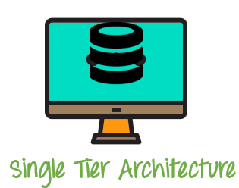

1.7.1.2 2-Tier Architecture
A 2 Tier Architecture in DBMS is a Database architecture where the presentation layer runs on a client (PC, Mobile, Tablet, etc.), and data is stored on a server called the second tier. Two tier architecture provides added security to the DBMS as it is not exposed to the end-user directly. It also provides direct and faster communication.
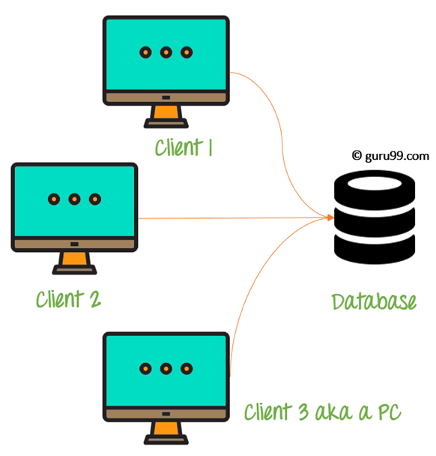

1.7.1.3 3-Tier Architecture
A 3 Tier Architecture in DBMS is the most popular client server architecture in DBMS in which the development and maintenance of functional processes, logic, data access, data storage, and user interface is done independently as separate modules. Three Tier architecture contains a presentation layer, an application layer, and a database server.
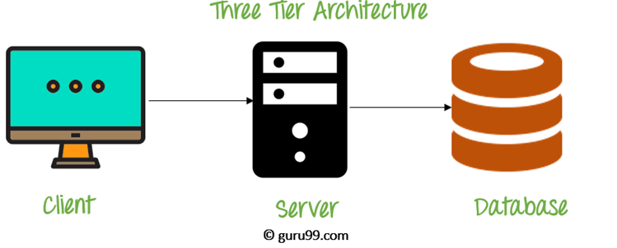

1.7.2 Core Functions of a DBMS
- Data Storage and Retrieval: Efficiently stores data and allows users to retrieve it using query languages like SQL.
- Data Manipulation: Facilitates operations such as inserting, updating, and deleting data.
- Schema Management: Defines and manages the structure of the database, including tables, relationships, and constraints.
- Security and Access Control: Ensures that only authorized users can access or modify data, often through authentication and authorization mechanisms.
- Backup and Recovery: Provides mechanisms to back up data and restore it in case of system failures.
- Concurrency Control: Manages simultaneous data access by multiple users, ensuring data consistency.

1.8 BUSINESS INTELLIGENCE
Business intelligence (BI) is a set of technological processes for collecting, managing and analysing organizational data to yield insights that inform business strategies and operations.
Business intelligence analysts transform raw data into meaningful insights that drive strategic decision-making within an organization.
Users can analyse this information to gain insights into how the business is performing and what it should do next.

1.8.1 Data Visualization and Predictive Reporting
- Storytelling with Data: Combining predictive analytics with data storytelling to communicate insights more effectively.
- Automated Reports: Research on how BI tools can generate automated reports with predictive insights, eliminating the need for manual analysis.
- Simplified Interpretation: Data visualization allows complex, multi-dimensional data to be presented in a simple, intuitive format (charts, graphs, heatmaps, etc.). It’s far easier to interpret data from a predictive model when visualized clearly.
- Faster Decision Making: By seeing trends and forecasts at a glance, decision-makers can make more timely, informed choices without sifting through raw numbers.
- Interactivity: Interactive dashboards and charts (drill-down features, hover-over tooltips) allow users to explore the data in greater detail. Users can click, filter, or zoom in on the forecast to gain deeper insights.
- Real-Time Insights: Visualization of real-time along with predictive insights helps businesses adjust on the fly.
- Engaging Storytelling: Good visualization can tell a story about the data, making it easier to share insights across teams and drive action.

1.8.2 Key Types of Data Visualizations for Predictive Reporting
- Line and Area Charts: Commonly used for showing trends over time
- Funnel Charts: Often used to show stages in a process
- Gauge/Speedometer Charts: Used for showing progress toward a target (e.g., how close you are to your forecasted sales goal).

1.9 DYNAMIC / MULTI PLATFORMS
Dynamic / Multi-Platform Integration refers to the ability to deliver data, insights, and applications seamlessly across multiple platforms and devices, offering flexibility and consistency in how users’ access and interact with information. This is especially important in business intelligence (BI) and predictive reporting, where organizations need to be able to analyse and visualize data in real-time, across a variety of devices and environments, and at different stages of the decision-making process.

1.9.1 Benefits of Dynamic / Multi-Platform BI
1.9.1.1 Flexibility and Accessibility
Users can access insights anytime, anywhere, on any device (mobile, desktop, etc.), whether in the office or on the go. This flexibility ensures that key decision-makers and team members can stay connected to the most current data, improving response times and agility.
1.9.1.2 Improved Decision-Making
With dynamic reporting and data visualization across devices, decision-makers can review forecasts, drill into data, and make informed decisions regardless of where they are. Predictions and insights can be updated in real-time, providing stakeholders with the most relevant information at the right time.
1.9.1.3 Enhanced Collaboration
Multi-platform BI tools often support collaborative features (e.g., shared dashboards, reports, comments) that allow teams to work together and align their decisions across different devices.
1.9.1.4 Consistency Across Devices
A consistent user experience across platforms ensures that employees can use the same set of tools, filters, and visuals regardless of the device, making the entire BI process smoother.

1.10 Weekly MIS Technical Report
1.10.1 LAST REPORT
Reporting Period: May 26 – May 30, 2025
Prepared By: Tsundzukani Nkuna
Department/ Job Title: MIS Automation Technician Trainee

1. Summary of Activities
- Deployment: Published HCBP Chemical Analysis Application on Line 2 and Induction Furnace Unit B.
- Issue Identified: In the Induction Furnace Level 2 Pc and Line 2 Control Room, the application displays only the date and time format without showing the current date and time values.

2. Issues Identified
Issue | Location | Date Reported | Status
Application displays only date/time format without current values   | Induction Furnace Level 2 Pc and Line 2 Control Room | May 30, 2025 | Attended But Not Resolved

3. Actions Taken
- Investigation: Initial assessment indicates that the application is not retrieving real-time data as expected.
- Pending Tasks: Update Microsoft Edge.

4. Planned Maintenance
- Update Microsoft Edge browser in Line 2 Control Room and Induction Furnace Level 2 PC.

5. Resolution Implemented
Resolution | Location | Date Resolved | Actions Taken (May 19, 2025) | Status
Updated Line 2 and Disa Line 2 Control Room and Compress air blow the PC | Line 2 Control Room, Disa Line 2 Control Room | June 06, 2025 – June 07, 2025 | - Updated Microsoft Edge browser in Line 2 and Disa Line 2 Control Room.  - Performed compressed air dusting of the PC in Line 2 and Disa Line 2 Control Room. | Resolved

1.10.2 LAST REPORT
Reporting Period: May 12 – May 16, 2025
Prepared By: Tsundzukani Nkuna
Department/ Job Title: MIS Automation Technician Trainee

1. Summary of Activities
- Deployment: Published HCBP Chemical Analysis Application on Line 1.
- Issue Identified: The application does not display the company logo as expected.

2. Issues Identified
Issue | Location | Date Reported | Status
Application on Line 1 Doesn’t Display Logo  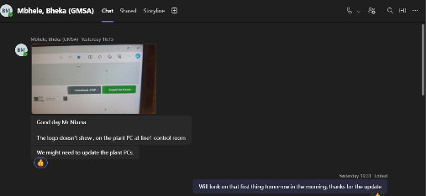 | Line 1 Control Room | May 16, 2025 | Attended and resolved

3. Matter Attended
- Initial investigation conducted; issue not yet resolved.
- Pending Tasks: Further diagnostics are required to identify the root cause.

4. Planned Maintenance
- Update Microsoft Edge browser in Line 1 Control Room.
- Perform compressed air dusting of the PC in Line 1 Control Room.

5. Resolution Implemented
Resolution | Location | Date Resolved | Actions Taken (May 19, 2025) | Status
Update Line 1 Control Room and Compress air blow the PC  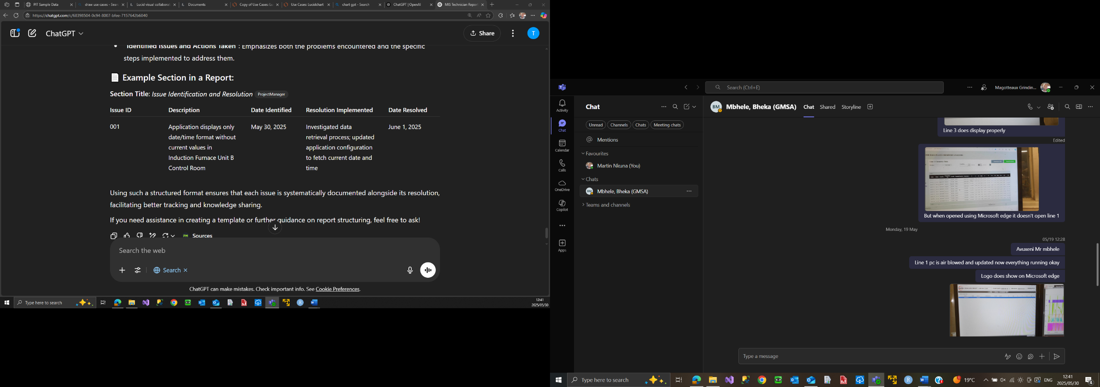 | Line 1 Control Room | May 19, 2025 | - Updated Microsoft Edge browser in Line 1 Control Room.  - Performed compressed air dusting of the PC in Line 1 Control Room. | Resolved

